

CCNA Discovery

Introducing Routing and Switching in the Enterprise

Lab 2.3.5 Configuring Basic Routing and Switching

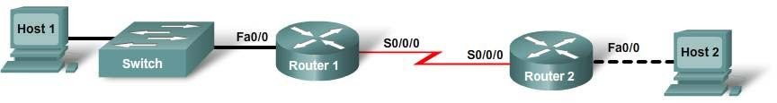

|  |  |  |  |  |  |  |  |
| --- | --- | --- | --- | --- | --- | --- | --- |
| **Device Designation** | **Host Name /**  **Interface** | **IP Address Fa0/0** | **VLAN 1**  **IP Address** | **Subnet Mask** | **IP Address S0/0/0** | **Subnet Mask** | **Default Gateway** |
| Router1 | R1 | 192.168.1.1 |  | 255.255.255.0 | 192.168.2.1 | 255.255.255.0 |  |
| Router2 | R2 | 192.168.3.1 |  | 255.255.255.0 | 192.168.2.2 | 255.255.255.0 |  |
| Switch | Switch1 |  | 192.168.1.5 | 255.255.255.0 |  |  | 192.168.1.1 |
| Host1 | PC1 | 192.168.1.10 |  | 255.255.255.0 |  |  | 192.168.1.1 |
| Host2 | PC2 | 192.168.3.10 |  | 255.255.255.0 |  |  | 192.168.3.1 |

# Objectives

* Configure static routes.
* Configure a routing protocol (RIP v2).
* Configure a switch management VLAN IP address.
* Test and verify configurations.

# Background / Preparation

This lab reviews the primary IOS commands used to manage, configure, and monitor devices in a multirouter network. In this lab, you will configure two routers using static routes and then using a routing protocol; configure a switch, including access to management functions; and configure two hosts. You will make and verify configuration changes on the switch. You will also verify network configurations and connectivity.

The following resources are required:

* Cisco 2960 switch or other comparable switch
* Two 1841 or other compatible Cisco routers with Fast Ethernet interfaces to connect to switch and host
* Two Windows-based PCs, at least one with a terminal emulation program
* At least one RJ45-to-DB-9 connector console cable
* Two straight-through Ethernet cables
* One crossover Ethernet cable
* Access to the PC command prompt
* Access to PC network TCP/IP configuration
* One null serial DCE-DTE V.35 cable set

**NOTE:** Go to the “Erasing and Reloading the Switch” instructions at the end of this lab. Perform those steps on the switch in this lab assignment before continuing.

**NOTE:** Go to the “Erasing and Reloading the Router” instructions at the end of this lab. Perform those steps on all routers in this lab assignment before continuing.

## Step 1: Connect PC1 to the switch

1. Connect PC1 to Fast Ethernet switch port Fa0/1. Configure PC1 to use the IP address, mask, and gateway as shown in the topology diagram.
2. Establish a terminal emulation session to the switch from PC1.

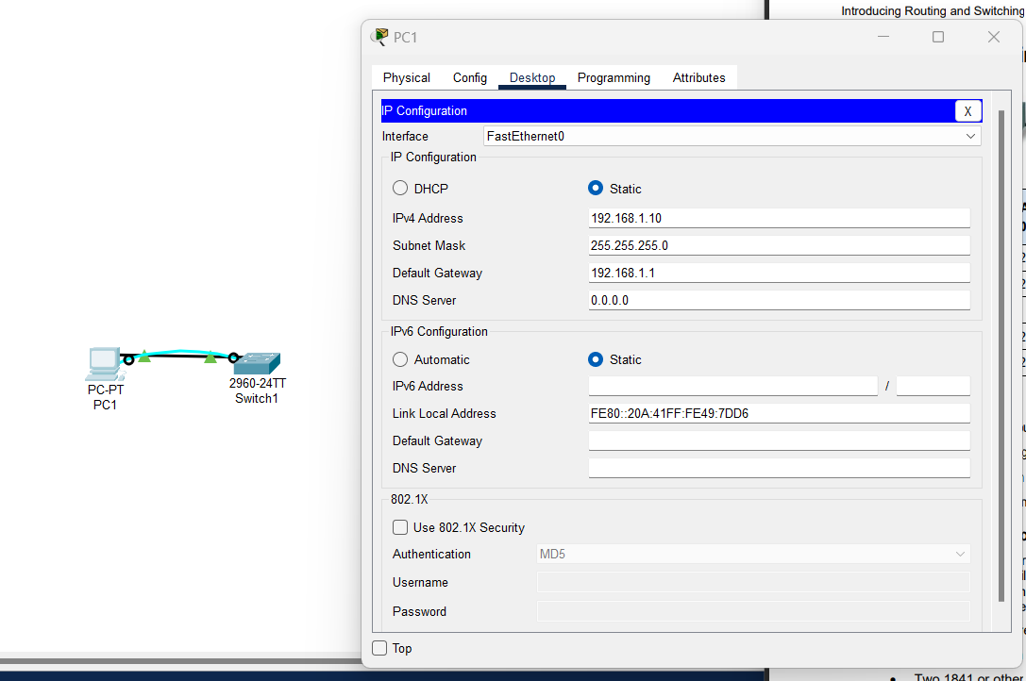

## Step 2: Perform an initial configuration on the switch

1. Configure the hostname of the switch as Switch1.

Switch>**enable** Switch#**configure terminal**

Switch(config)#**hostname Switch1**

1. Set the privileged EXEC mode password to **cisco**.

Switch1(config)#**enable password cisco**

1. Set the privileged EXEC mode secret password to **class**.

Switch1(config)#**enable secret class**

1. Configure the console and virtual terminal lines to use a password and require it at login.

Switch1(config)#**line console 0** Switch1(config-line)#**password cisco** Switch1(config-line)#**login** Switch1(config-line)#**line vty 0 15** Switch1(config-line)#**password cisco** Switch1(config-line)#**login** Switch1(config-line)#**end**

1. Exit from the console session and log in again.

Which password was required?

**The line console 0 password “cisco” was required to login again and access the Switch> prompt.**

Which password is required to access privilege EXEC mode and why?

**The enable secret password “class” was required to access privilege EXEC mode. This is**

**because both the enable and secret passwords are configured which can only be accessed**

**using the secret password.**

## Step 3: Configure the switch management interface on VLAN 1

1. Enter the interface configuration mode for VLAN 1.

Switch1(config)#**interface vlan 1**

1. Set the IP address, subnet mask, and default gateway for the management interface.

Switch1(config-if)#**ip address 192.168.1.5 255.255.255.0**

Switch1(config-if)#**no shutdown**

Switch1(config-if)#**exit**

Switch1(config)#**ip default-gateway 192.168.1.1**

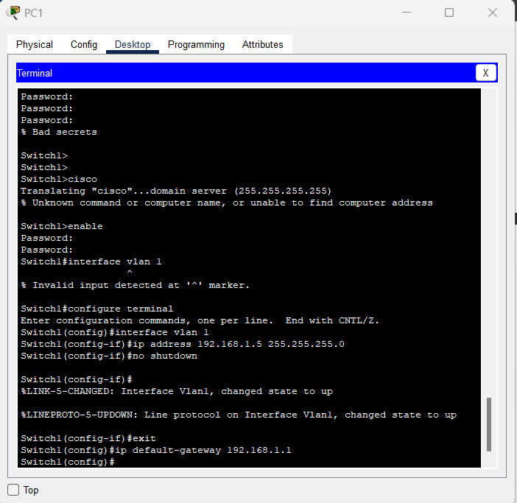

1. Why does interface VLAN1 require an IP address in this LAN?

**Interface VLAN1 requires an IP address in this LAN in order to access and manage the switch**

**through terminals, including the Telnet.**

1. What is the purpose of the default gateway?

**Default gateway allows us to access other networks.**

## Step 4: Verify configuration of the switch

1. Verify that the IP address of the management interface on the switch VLAN 1 and the IP address of PC1 are on the same local network. Use the **show running-config** command to check the IP address configuration of the switch.

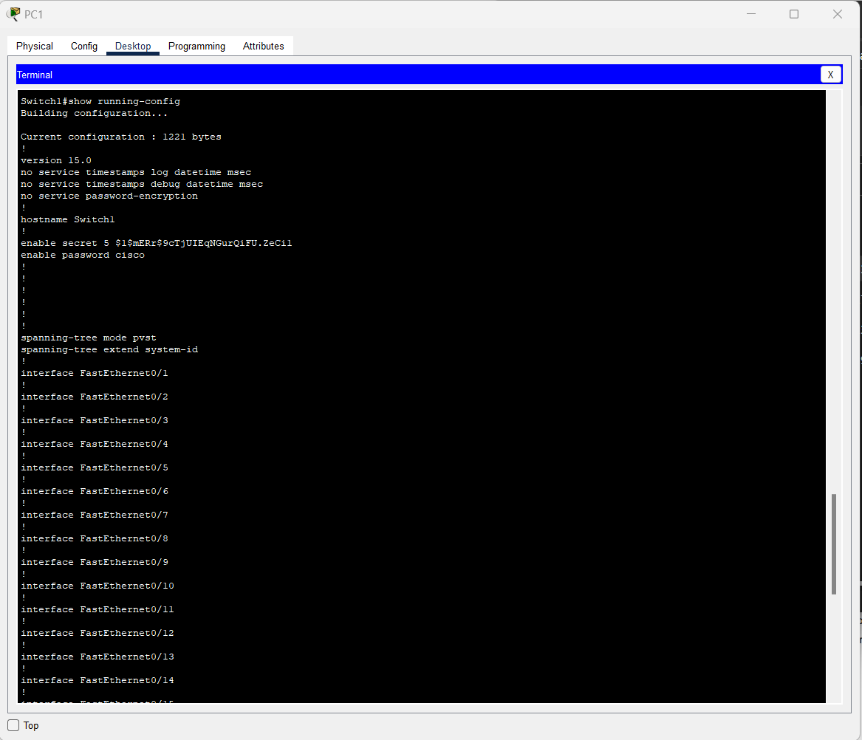

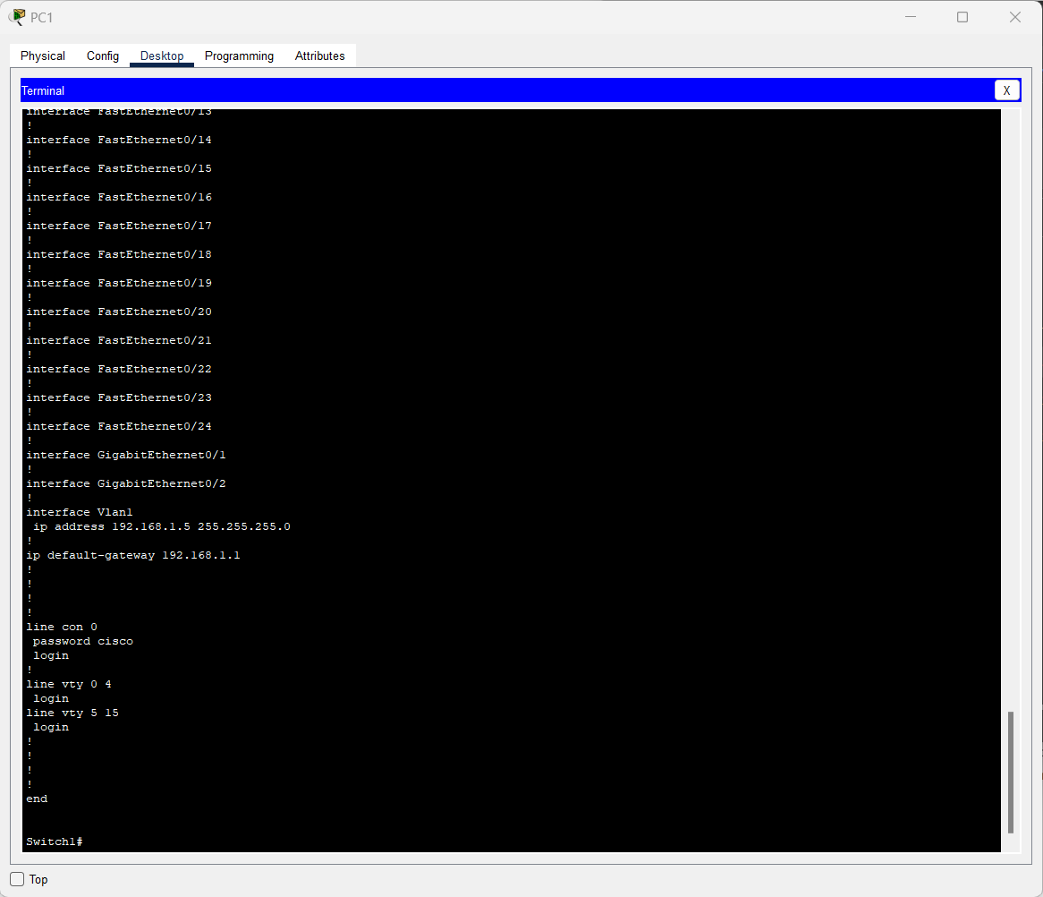

1. Save the configuration.

## Step 5: Perform basic configuration of router R1

1. Connect switch port Fa0/3 to interface Fa0/0 of router R1.
2. Establish a terminal emulation session to router R1 from PC1.

1. Enter privileged EXEC mode, and then global configuration mode.

Router#**configure terminal**

Enter configuration commands, one per line. End with CNTL/Z.

Router(config)#

1. Configure the router name as R1.

Router(config)#**hostname R1**

1. Disable DNS lookup.

R1(config)#**no ip domain-lookup**

Why would DNS lookup be disabled in a lab environment?

**Disabling DNS lookup in a lab environment keeps the router from attempting to resolve**

**typographical errors in domain names.**

1. Configure the EXEC mode password.

R1(config)#**enable secret class**

Why is it not necessary to use the **enable password** *password* command?

**The enable secret password is already set to default by the router.**

1. Configure a message-of-the-day banner using the **banner motd** command.

**NOTE**: When you use the banner motd command, you must issue a delimited character, a character to let the router know is the beginning (or ending) part of the message. Examples of delimiting characters include +, @, %, or $. Once you enter the beginning delimited character, you press Enter and type the lines you want to appear when someone accesses a network device. Press Enter after each line. When finished, type the same delimiting character.

R1(config)#banner motd +

************************************************** Authorized Users Only!

**************************************************

+

R1(config)#

Where does this banner display?

**The MOTD banner displays in the login prompt every time a user tries to access the router.**

1. Configure the console and virtual terminal lines to use a password and require it at login.

R1(config)#**line console 0** R1(config-line)#**password cisco** R1(config-line)#**login** R1(config-line)#**line vty 0 4** R1(config-line)#**password cisco** R1(config-line)#**login**

R1(config-line)#**end**

## Step 6: Configure interfaces and static routing on router R1

1. Configure the FastEthernet 0/0 interface with the IP address 192.168.1.1/24.

R1(config)#**interface fastethernet 0/0**

R1(config-if)#**ip address 192.168.1.1 255.255.255.0**

R1(config-if)#**no shutdown**

1. Configure the Serial 0/0/0 interface with the IP address 192.168.2.1/24. Set the clock rate to 64000.

R1(config-if)#**interface serial 0/0/0**

R1(config-if)#**ip address 192.168.2.1 255.255.255.0**

R1(config-if)#**clock rate 64000**

R1(config-if)#**no shutdown**

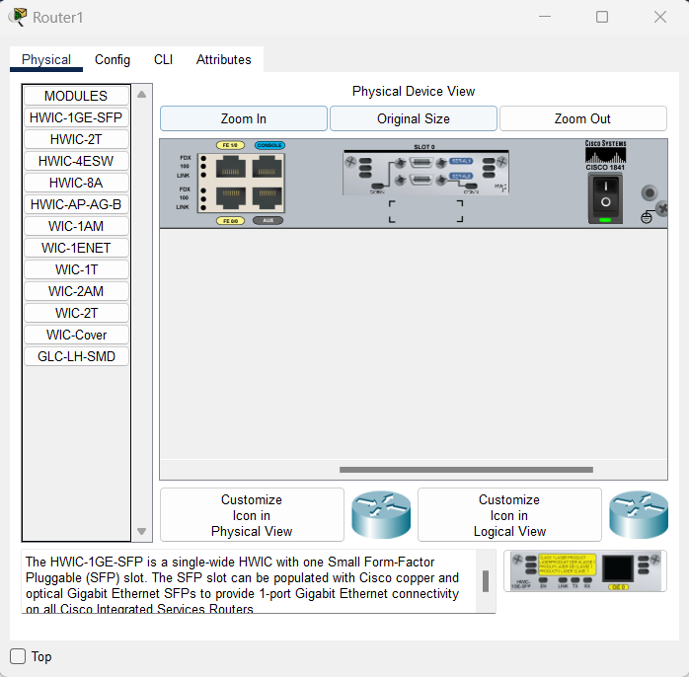

1. Return to global configuration mode.
2. Create a static route to enable R1 to reach the network attached to the R2 Fa0/0 interface. Use the next hop interface on R2 as the path to this network.

### R1(config)#ip route 192.168.3.0 255.255.255.0 192.168.2.2

Why is this static route the only one required?

**Other networks are directly connected to R1 or Router1, which is why a static route is required.**

1. Return to privileged EXEC mode.
2. Save the configuration.
3. Shut down R1.

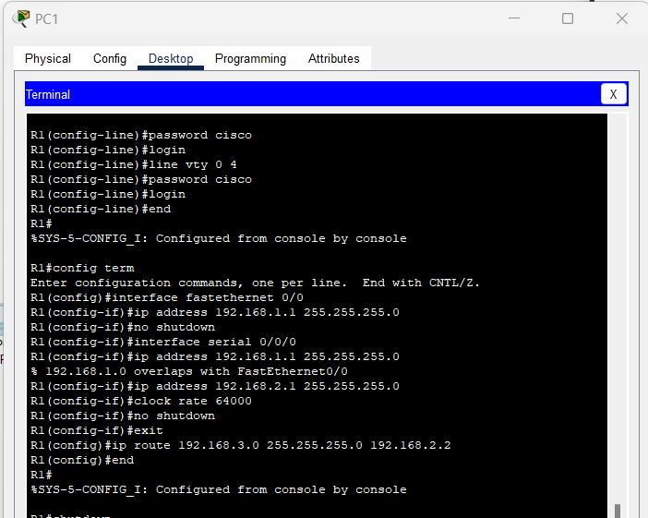

## Step 7: Connect PC2 to router R2

1. Connect PC2 to the FastEthernet interface 0/0 of router R2 and assign the IP address, subnet mask, and default gateway according to the lab IP address table.

What kind of cable is required to connect a host directly to a router Ethernet port?

**A crossover cable is required to connect a host directly to a router Ethernet port.**

1. Establish a terminal emulation session with router R2 from PC2.

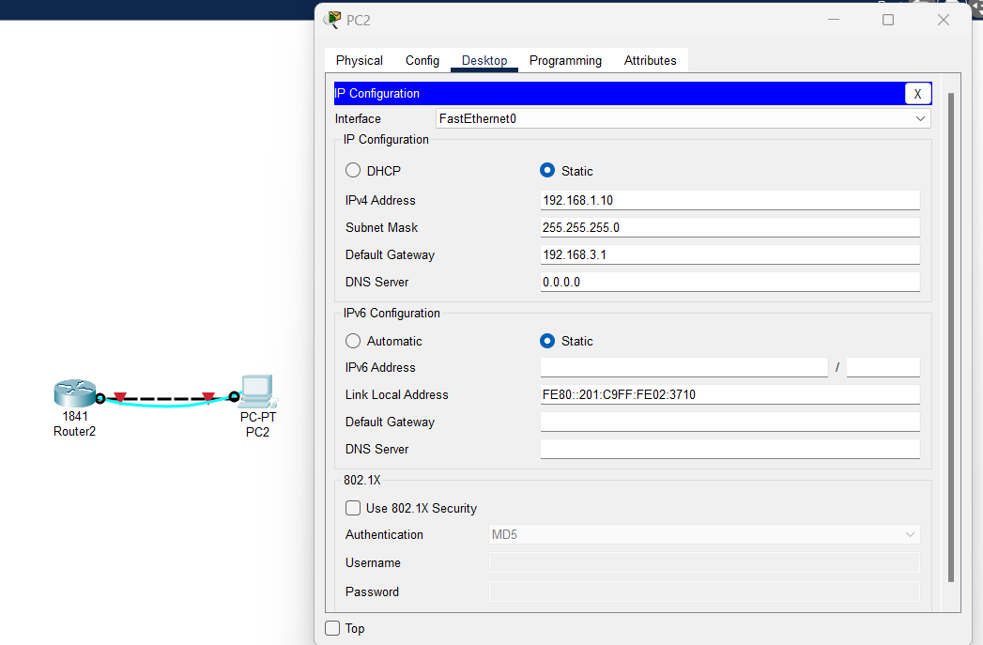

## Step 8: Perform basic configuration of router R2

1. Repeat Step 5, a through h, making the hostname R2.
2. Configure the Serial 0/0/0 interface with the IP address 192.168.2.2/24.

R2(config)#**interface serial 0/0/0**

R2(config-if)#**ip address 192.168.2.2 255.255.255.0**

R2(config-if)#**no shutdown**

1. Configure the FastEthernet 0/0 interface with the IP address 192.168.3.1/24.

R2(config-if)#**interface fastethernet 0/0**

R2(config-if)#**ip address 192.168.3.1 255.255.255.0**

R2(config-if)#**no shutdown**

1. Create a static route to enable R2 to reach the network attached to the R1 Fa0/0 interface. Use the next hop interface on R1 as the path to this network.

### R2(config)#ip route 192.168.1.0 255.255.255.0 192.168.2.1

1. Return to privileged EXEC mode.
2. Save the configuration.
3. Shut down R2.

## Step 9: Connect the internetwork

1. Connect R1 and R2 using a serial cable between their configured serial interfaces.
2. Verify that the serial DCE cable is connected to R1 and that the serial DTE cable is connected to R2.
3. Start up both routers, and log in.

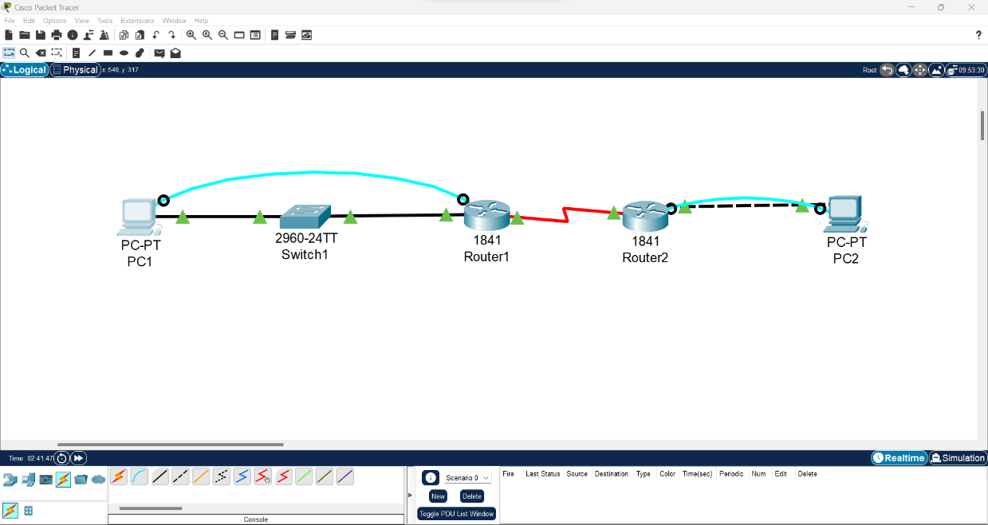

## Step 10: Verify and test the configurations

1. To verify that PC1 and Switch1 are correctly configured, ping the switch IP address from PC1.

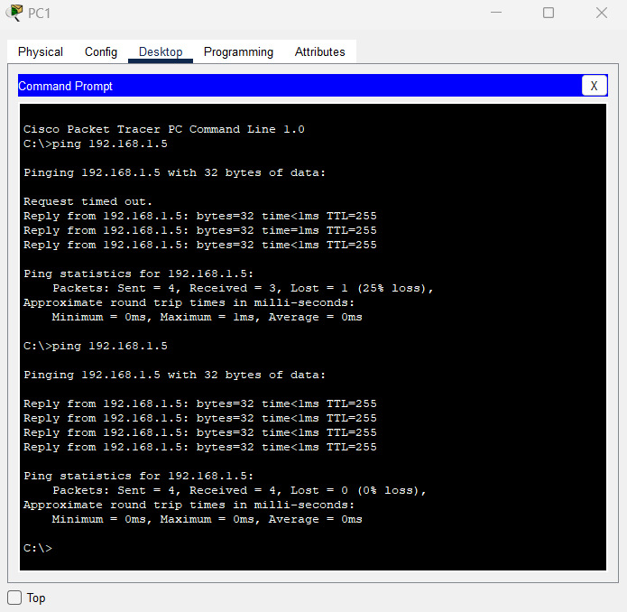

1. To verify that Switch1 and R1 are correctly configured, ping the router Fa0/0 interface (default gateway) IP address from the Switch1 CLI.

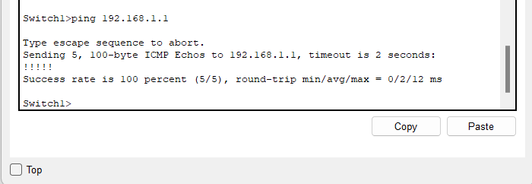

1. To verify that PC2 and R2 are correctly configured, ping the router Fa0/0 interface from PC2. Were the pings successful? **Yes**

If the ping is not successful, verify the connections and configurations again. Check to ensure that all cables are correct and that connections are seated. Check the host, switch, and router configurations.

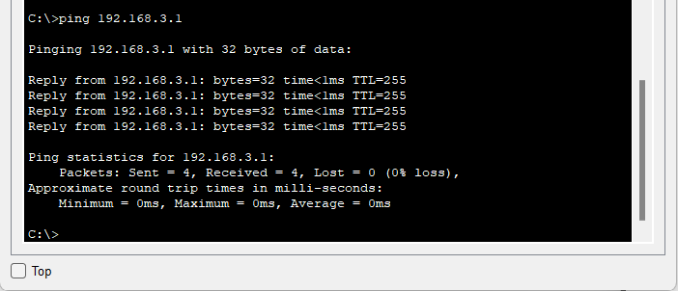

1. To verify the network has been configured correctly for static routing, ping PC2 from PC1.

If the ping is not successful, troubleshoot the connections and configurations until PC1 can successfully ping PC2.

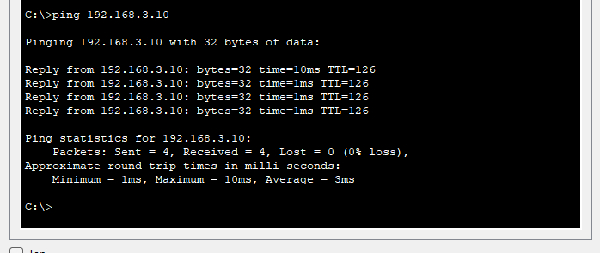

1. Verify that the routing tables have routes to all configured networks by using the **show ip route**

Command.

What does the “S” indicate?

**The route as manually configured as a Static Route.**

1. Verify the router interface configurations using the **show ip interface brief** command.

What should the output indicate for correctly configured, active interfaces?

**The Status and Protocol indicates “up” for correctly configured and active interfaces.**

What should the output indicate for any interface that has not been configured?

**The status is administratively down as well as the protocol.**

1. View devices from R1’s terminal session using the **show cdp neighbors** command.

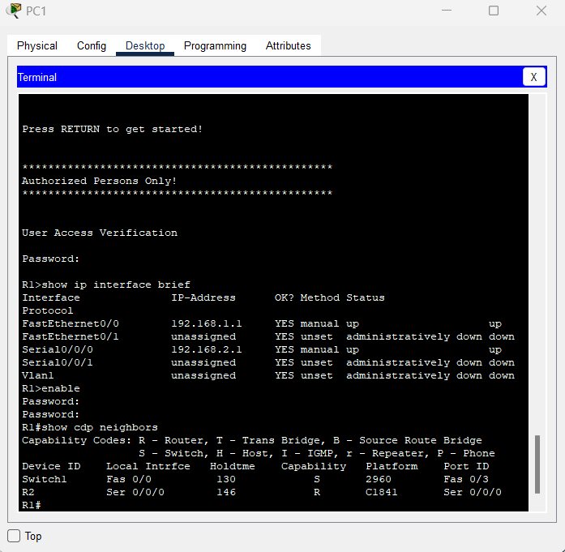

If an additional switch is added between PC2 and R2, would that switch appear in this command

output? **No**  Why or why not? **CDP only displays and shows those directly-connected Cisco devices.**

## Step 11: Remove Static Route and configure a routing protocol on router R1

1. Remove the static route to 192.168.3.0.

### R1(config)#no ip route 192.168.3.0 255.255.255.0 192.168.2.2

1. Enable RIP v2 routing and advertise the participating networks.

R1(config)#**router rip**

R1(config-router)#**version 2**

R1(config-router)#**network 192.168.1.0**

R1(config-router)#**network 192.168.2.0**

1. Return to privileged EXEC mode.
2. Save the configuration.

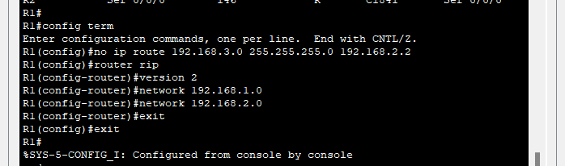

## Step 12: Remove Static Route and configure a routing protocol on router R2

1. Remove the static route to 192.168.1.0.

### R2(config)#no ip route 192.168.1.0 255.255.255.0 192.168.2.1

1. Enable RIP v2 routing and advertise the participating networks.

R2(config)#**router rip**

R2(config-router)#**version 2**

R2(config-router)#**network 192.168.2.0**

R2(config-router)#**network 192.168.3.0**

1. Return to privileged EXEC mode.
2. Save the configuration.

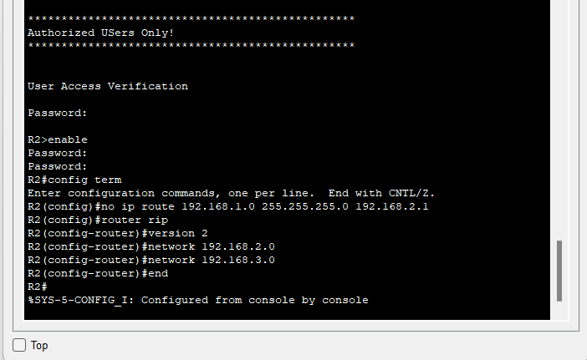

## Step 13: Verify and test the configurations

1. To verify that PC1 and Switch1 are correctly configured, ping the switch IP address from PC1.

1. To verify that Switch1 and R1 are correctly configured, ping the router Fa0/0 interface (default gateway) IP address from the Switch1 CLI.

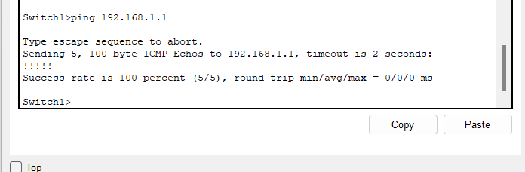

1. To verify that PC2 and R2 are correctly configured, ping the router Fa0/0 interface from PC2. Were the pings successful? **Yes**

If the ping is not successful, verify the connections and configurations again. Check to ensure that all cables are correct and that connections are seated. Check the host, switch, and router configurations.

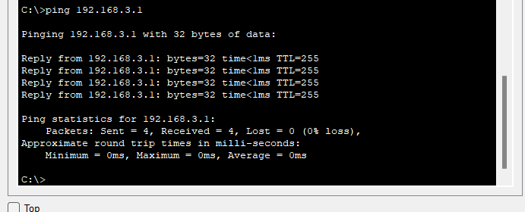

1. To verify the network has been configured correctly for static routing, ping PC2 from PC1.

If the ping is not successful, troubleshoot the connections and configurations until PC1 can successfully ping PC2.

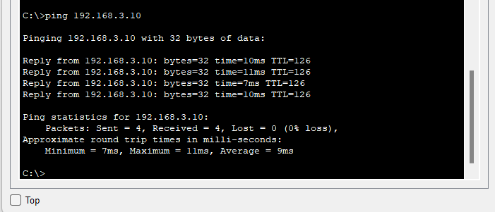

1. Verify that the routing tables have routes to all configured networks by using the **show ip route**

command. R2’s routing table should display:

What does the “R” indicate?

**“R” indicates that the route is learned through RIP.**

On R1, which route would be displayed with an “R”? **Network 192.168.3.0**

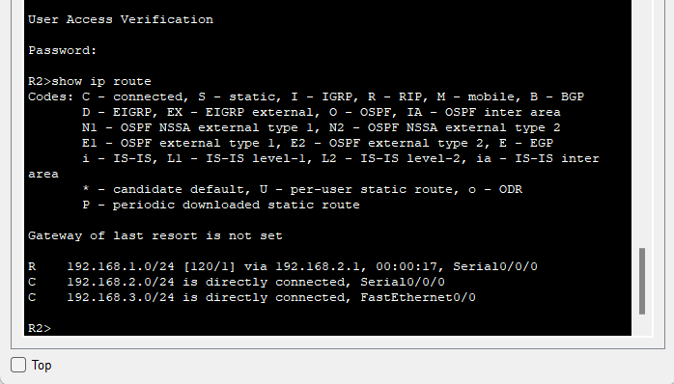

1. Verify the router interface configurations using the **show ip interface brief** command.

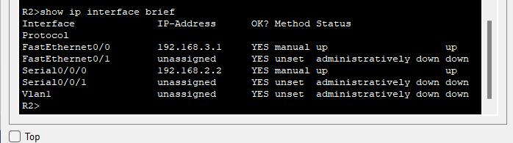

1. View devices from R1’s terminal session using the **show cdp neighbors** command.

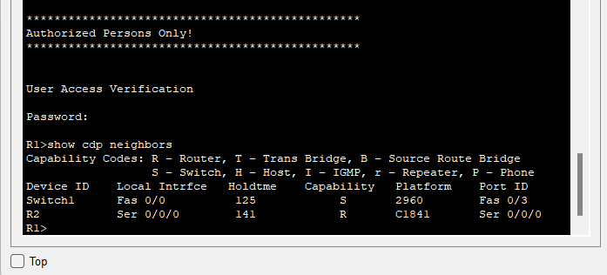

## Step 14: Use the switch management interface

1. Open a command prompt on PC1, and enter the **telnet** command followed by the IP address assigned to management interface VLAN 1.
2. Enter the vty password configured in Step 2 to gain access to the switch.
3. At the switch prompt, issue the **show version** command.

Switch1>s**how version**

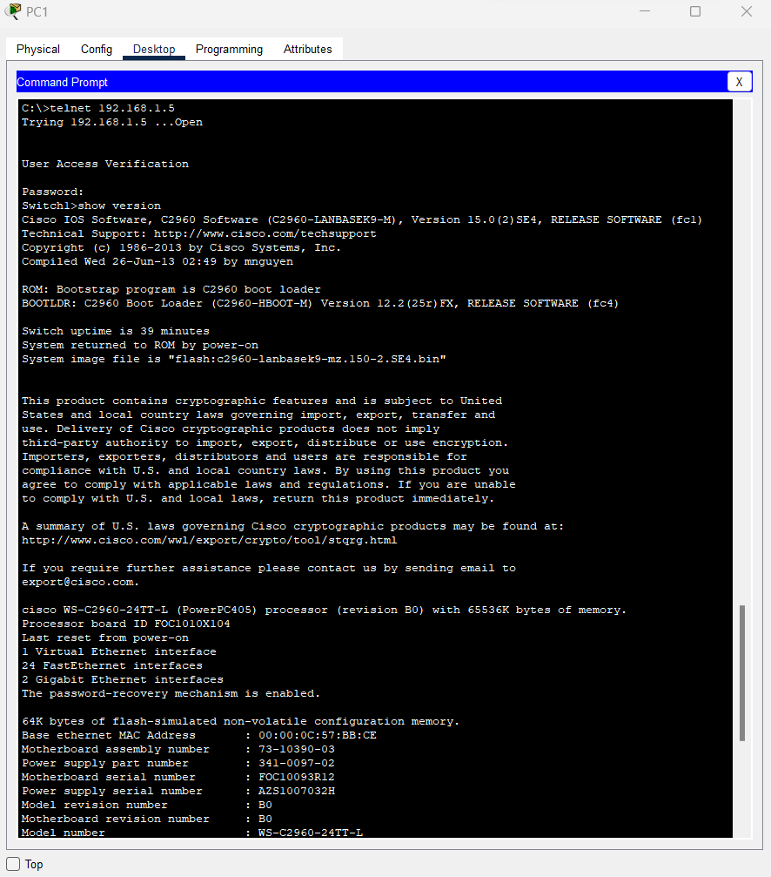

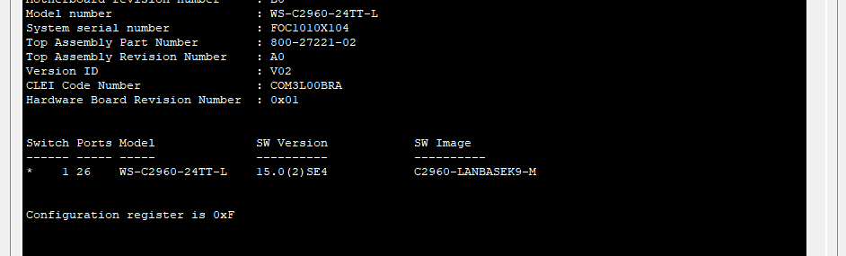

1. What is the Cisco IOS version of this switch? **Cisco IOS version of this switch is SW Version 15.0**
2. Determine which MAC addresses the switch has learned by using the **show mac-address-table**

command at the privileged EXEC mode prompt.

Switch1#**show mac-address-table**

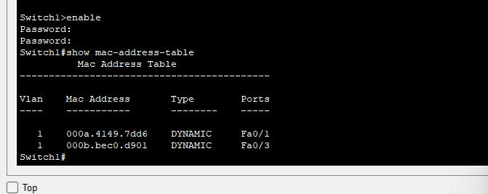

How can you determine the MAC address belonging to PC1?

**Search for the MAC addresses associated with port Fa0/1.**

At a PC1 command prompt, type ipconfig/all.

Does PC1’s MAC address match one in the switch table? **Yes**

1. To allow the switch port FastEthernet 0/1 to accept only one device, configure port security as follows:

Switch1(config)#**interface fastethernet 0/1** Switch1(config-if)#**switchport mode access** Switch1(config-if)#**switchport port-security**

Switch1(config-if)#**switchport port-security mac-address sticky**

Switch1(config-if)#**end**

1. Check the port security settings.

Switch1#**show port-security**

Secure Port MaxSecureAddr CurrentAddr SecurityViolation Security Action (Count) (Count) (Count)

Fa0/1 1 1 0 Shutdown

If a host other than PC1 attempts to connect to Fa0/1, what will happen?

**The connection will be disconnected/shut down.**

It is sometimes necessary to set the speed and duplex of a port to ensure that it operates in a particular mode. You can set the speed and duplex with the **duplex** and **speed** commands while in interface configuration mode. To force FastEthernet port 5 to operate at half duplex and 10 Mbps, issue the following commands:

Switch>**enable** Switch#**configure terminal**

Switch(config-if)#**interface fastethernet 0/5**

Switch(config-if)#**speed 10** Switch(config-if)#**duplex half** Switch(config-if)#**end**

Switch#

1. Issue the **show interfaces** command. What is the duplex and speed setting for Fa0/5 now?

**Fa0/5 is now half duplex and has the speed of 10 mb/s.**

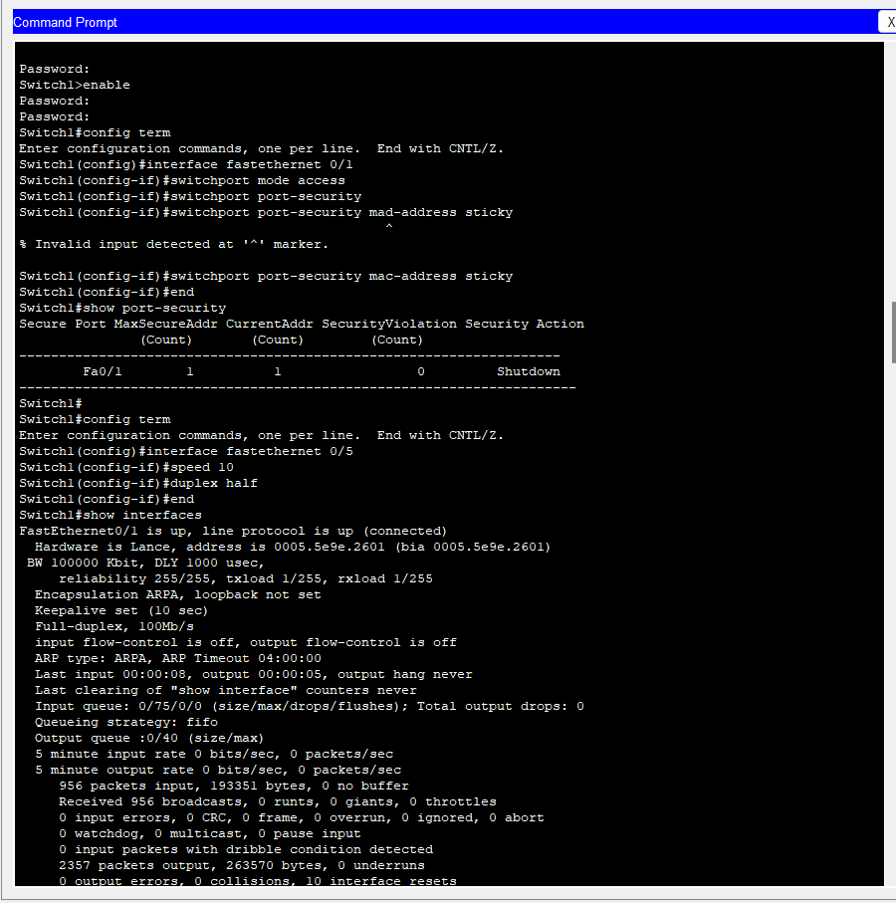

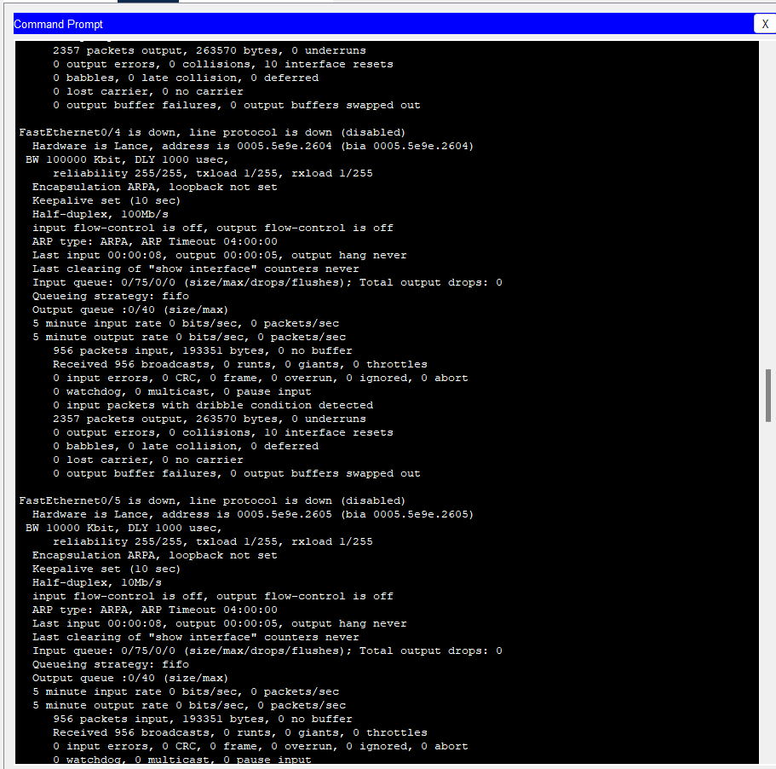

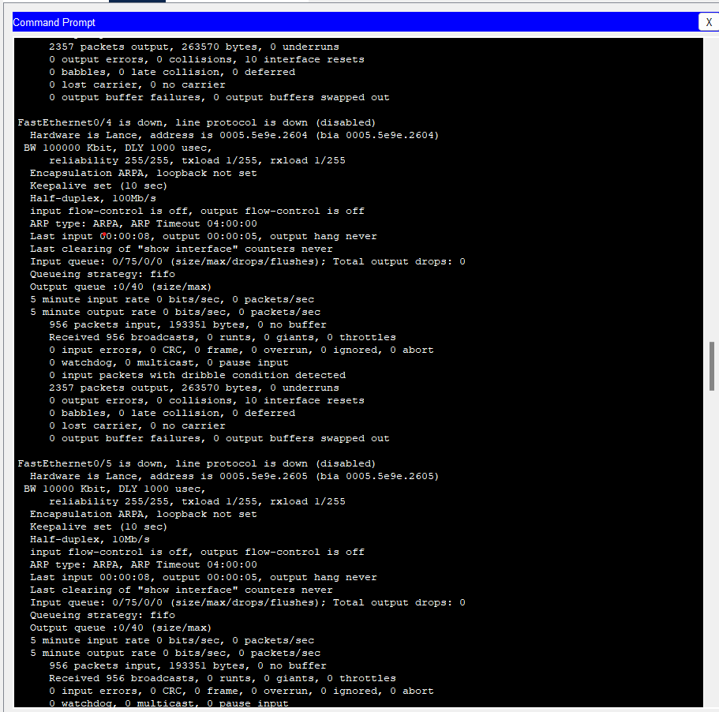

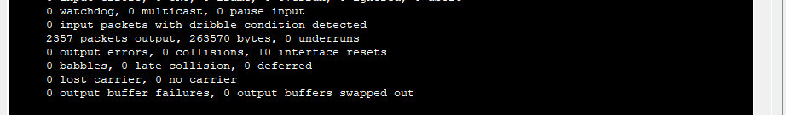

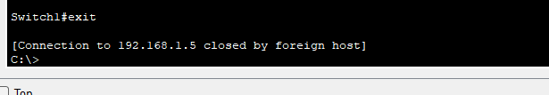

1. Enter **quit** at the switch command prompt to terminate the Telnet session.

## Step 15: Reflection

1. Describe a situation in which you would use virtual terminal access to manage a switch, as you did in Step 11.

**Virtual terminal access can be used to manage the switch if the switch is located in another**

**location and direct connection is impossible.**

1. Which symbol is used to show a successful ping in the Cisco IOS software? **Exclamation point “!”**
2. Which commands used in this lab would provide the best documentation for this network?

**show interfaces, show ip route, show ip interface brief, and show cdp neighbors.**

1. This lab gave you an opportunity to review and display your knowledge of configuration commands. If you were asked to state three rules for “best practices” in device configuration, what would they be?

* **Avoid typographical errors, specifically when typing commands.**
* **Always save your progress.**
* **Make sure to input and assign the correct IP addresses to each device.**

1. Erase and reload all devices.

# Erasing and Reloading the Switch

For the majority of the labs in CCNA Discovery, it is necessary to start with an unconfigured switch. Using a switch with an existing configuration may produce unpredictable results. The following instructions prepare the switch prior to performing the lab so that previous configuration options do not interfere. Instructions are provided for the 2900 and 2950 series switches.

1. Enter into privileged EXEC mode by typing **enable**. If prompted for a password, enter **class** (if that does not work, ask the instructor).

Switch>**enable**

1. Remove the VLAN database information file.

Switch#**delete flash:vlan.dat**

Delete filename [vlan.dat]?**[Enter]** Delete flash:vlan.dat? [confirm] **[Enter]**

If there was no VLAN file, this message is displayed:

%Error deleting flash:vlan.dat (No such file or directory)

1. Remove the switch startup configuration file from NVRAM.

Switch#**erase startup-config**

The responding line prompt is:

Erasing the nvram filesystem will remove all files! Continue? [confirm]

Press **Enter** to confirm.

The response should be:

Erase of nvram: complete

1. Check that VLAN information was deleted.

Verify that the VLAN configuration was deleted in Step b using the **show vlan** command. If previous VLAN configuration information (other than the default management VLAN 1) is still present, you must power cycle the switch (hardware restart) instead of issuing the **reload** command. To power cycle the switch, remove the power cord from the back of the switch or unplug it, and then plug it back in. If the VLAN information was successfully deleted in Step b, go to Step e and restart the switch using the **reload** command.

1. Restart the software using the **reload** command.

**NOTE:** This step is not necessary if the switch was restarted using the power cycle method.

* 1. At the privileged EXEC mode, enter the **reload** command:

Switch(config)#**reload**

The responding line prompt is:

System configuration has been modified. Save? [yes/no]:

* 1. Type **n,** and then press **Enter**. The responding line prompt is:

Proceed with reload? [confirm] **[Enter]**

The first line of the response is:

Reload requested by console.

After the switch has reloaded, the line prompt is:

Would you like to enter the initial configuration dialog? [yes/no]:

* 1. Type **n,** and then press **Enter**. The responding line prompt is:

Press RETURN to get started! **[Enter]**

# Erasing and Reloading the Router

1. Enter the privileged EXEC mode by typing **enable**.

Router>**enable**

1. In privileged EXEC mode, enter the **erase startup-config** command.

Router#**erase startup-config**

The responding line prompt is:

Erasing the nvram filesystem will remove all files! Continue? [confirm]

1. Press **Enter** to confirm.

The response is:

Erase of nvram: complete

1. In privileged EXEC mode, enter the **reload** command.

Router(config)#**reload**

The responding line prompt is:

System configuration has been modified. Save? [yes/no]:

1. Type **n** and then press **Enter**. The responding line prompt is:

Proceed with reload? [confirm]

1. Press **Enter** to confirm.

In the first line of the response is:

Reload requested by console.

After the router has reloaded the line prompt is:

Would you like to enter the initial configuration dialog? [yes/no]:

1. Type **n** and then press **Enter**. The responding line prompt is:

Press RETURN to get started!

1. Press **Enter**.

The router is ready for the assigned lab to be performed.

# SDM Router Basic IOS Configuration to Bring Up SDM

If the startup-config is erased in an SDM router, SDM will no longer come up by default when the router is restarted. It will be necessary to build a basic config as follows. Further details regarding the setup and use of SDM are can be found in the SDM Quick Start Guide:

<http://www.cisco.com/en/US/products/sw/secursw/ps5318/products_quick_start09186a0080511c89.html#wp44788>

1. Set the router Fa0/0 IP address.

This is the interface that a PC will connect to using a browser to bring up SDM. The PC IP address should be set to 10.10.10.2 255.255.255.248.

**NOTE:** An SDM router other than the 1841 may require connection to a different port to access SDM.

Router(config)#**interface Fa0/0**

Router(config-if)#**ip address 10.10.10.1 255.255.255.248**

Router(config-if)#**no shutdown**

1. Enable the router's HTTP/HTTPS server, using the following Cisco IOS commands:

Router(config)#**ip http server** Router(config)#**ip http secure-server** Router(config)#**ip http authentication local**

1. Create a user account with privilege level 15 (enable privileges).

Router(config)#**username** <username> **privilege 15 password 0** <password>

Replace <username> and <password> with the username and password that you want to configure.

1. Configure SSH and Telnet for local login and privilege level 15.

Router(config)#**line vty 0 4**

Router(config-line)#**privilege level 15** Router(config-line)#**login local** Router(config-line)#**transport input telnet**

Router(config-line)#**transport input telnet ssh**

Router(config-line)#**exit**